LAB WEEK 2

Task 2 screenshot:

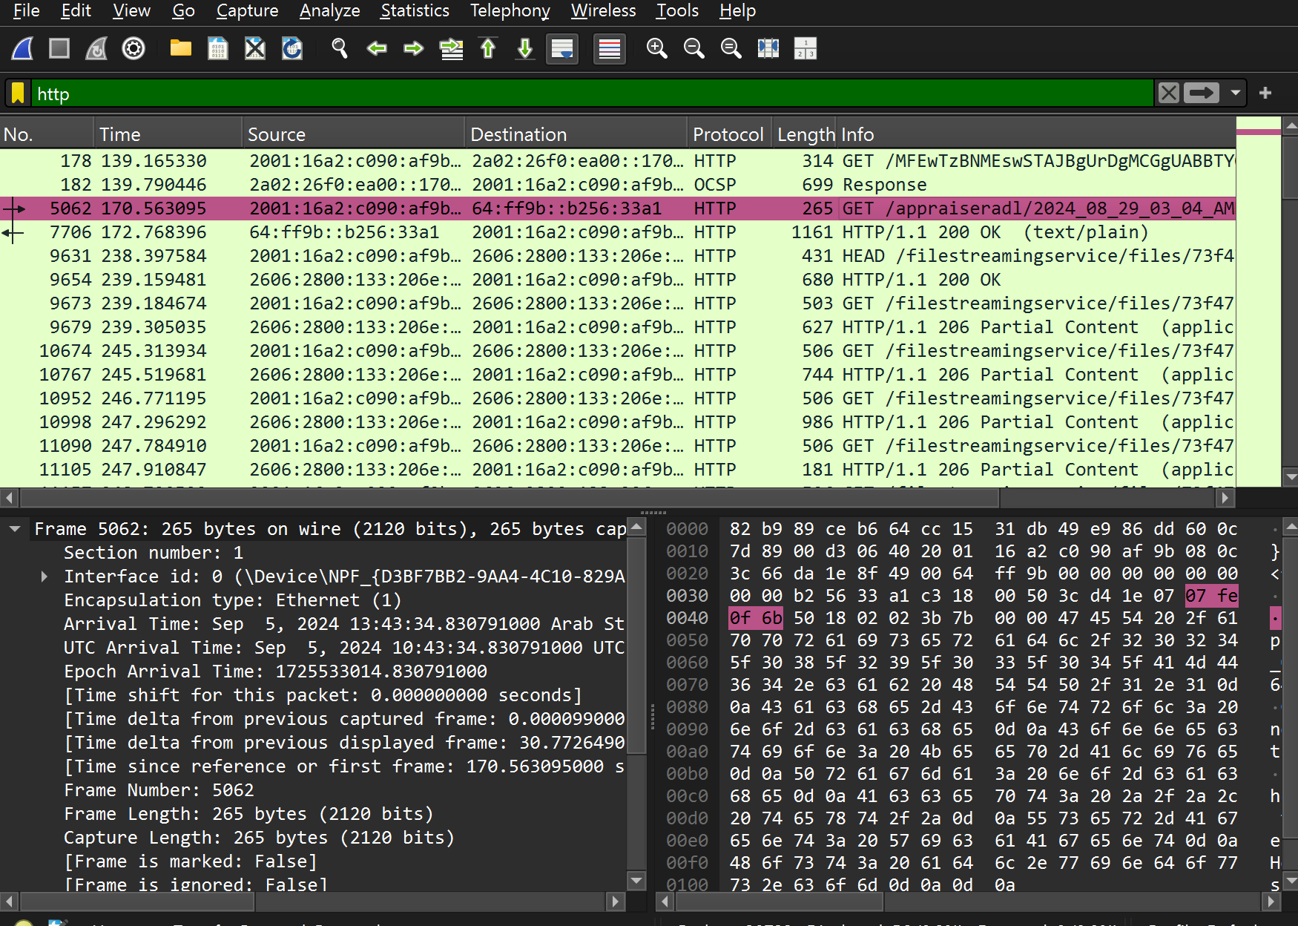

Filtered the packets to only show HTTP packets,

The method is GET, response code is 200 OK.

URL: <https://lms.qu.edu.sa/webapps/portal/execute/tabs/tabAction?tab_tab_group_id=_1_1>

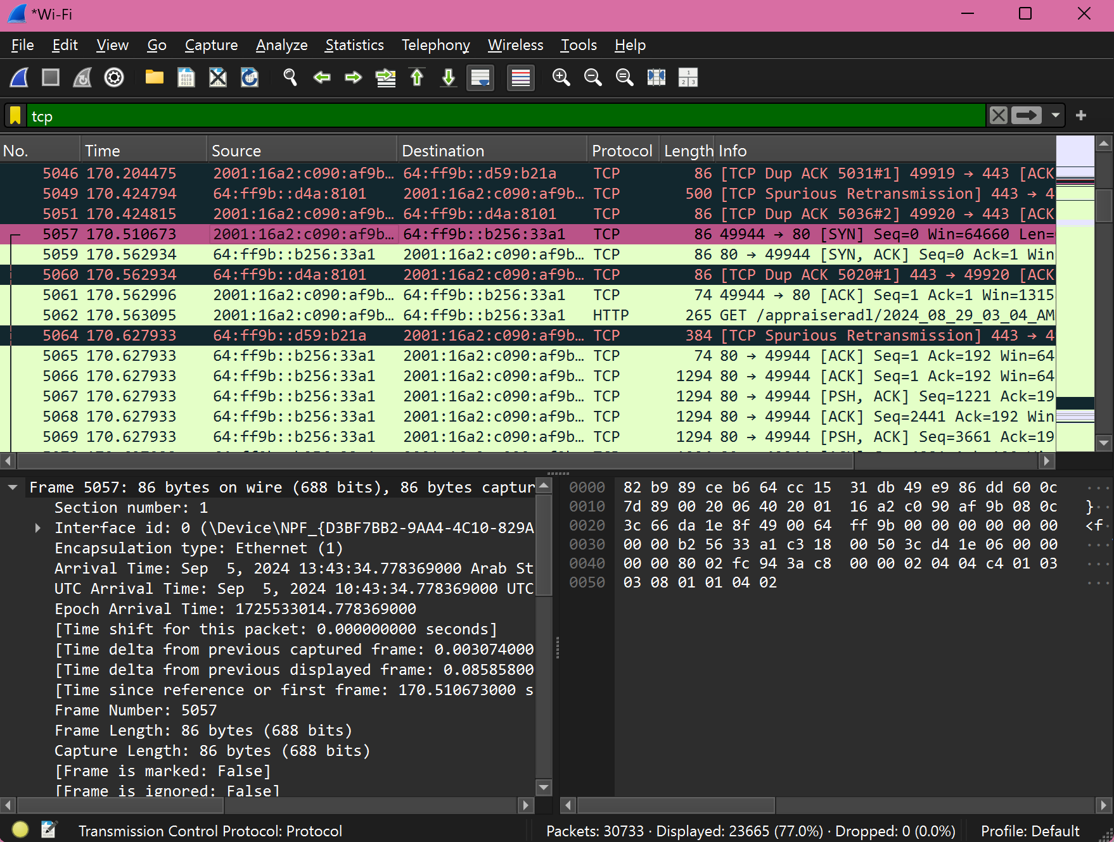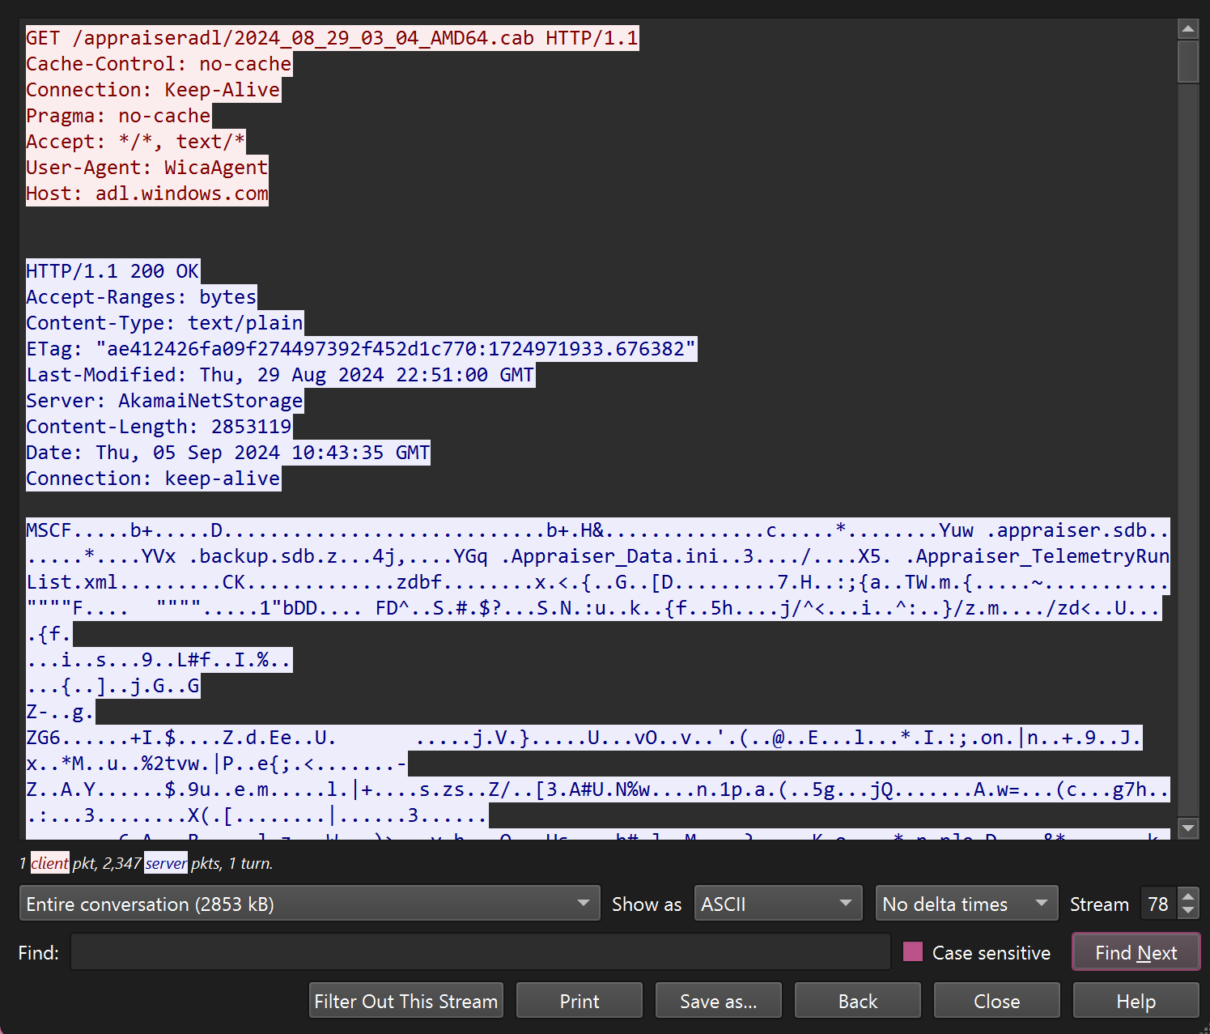

Sequence Numbers, 0,

Part 3:

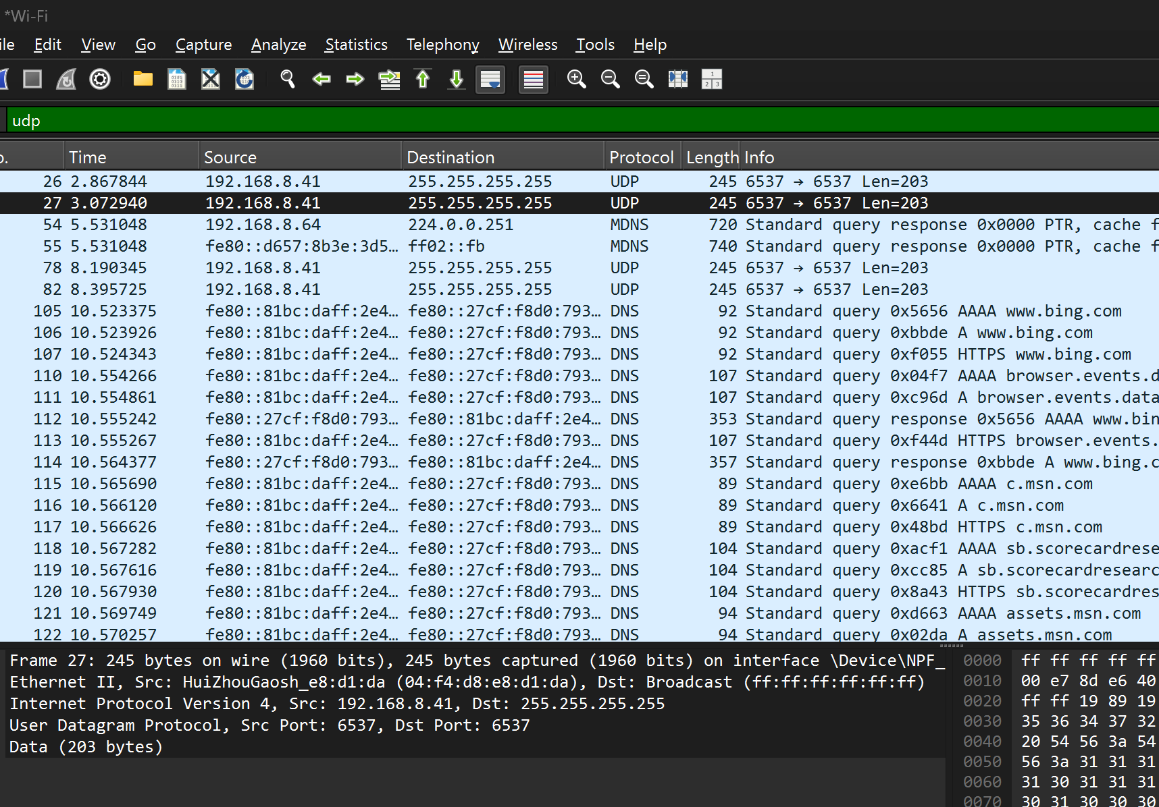

Source: 192.168.8.41

Destination: 255.255.255.255

Port 6537

Length: 203

Part 4:

Reliability: TCP, Reason: It focuses on delivering packets correctly

Integrity and Ordering: TCP, Same reason as above, it’s more focused on correctness rather than speed.

Use cases:

UDP: For delivering things like video or streams as it is fast

TCP: For delivering things like messages that require to be strictly correct and ordered

Performance:

UDP: Fast, not reliable

TCP: Slower than UDP but reliable